**Data Discrepancies: Caregiver consent on behalf of child (ChildCaregiverConsent.csv)**

***Discrepancy 1: old_matpid values do not propagate across siblings***

**Supporting R code:**

* `raw_dfs$CaregiverChildConsent` = raw CaregiverChildConsent.csv export from EDC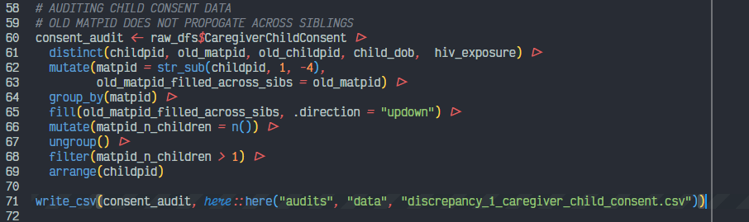

**Outputs:** discrepancy_1_caregiver_child_consent.csv

**Notes:**

* In the CargiveChildConsent csv export, old_matpid values are not propagating across sets/families of siblings (i.e., only present in record for one sibling) that share a common matpid
* Seems to only be affecting sibling pairs where the first child is from a prior cohort and the second child was born into the FLOURISH cohort. Children from the prior cohort have a value for old_matpid but their siblings born into the FLOURISH study do not.