| Tshilo Dikotla/Karabo-Senaite Meeting Agenda |
| --- |

|  |  |
| --- | --- |
| Location: | Zoom Call (<https://zoom.us/j/609012711>) |
| Date: | Tuesday, March 3rd, 2020 |
| Time: | 7:00 AM (CT) / 8:00 AM (ET) / 3:00 PM (CAT) |

# Agenda details:

## Karabo Senaite access for Kate & Sarah

## Data we need from EDC requisitions

### Specimens received by lab; specimens sent for assay and their results; specimens aliquoted for storage

|  |  |
| --- | --- |
| EDC Panel Names | |
| Infant | Maternal |
| DBS | CD4 |
| DNA PCR | Fasting glucose |
| Infant ELISA | Glucose 1 hr |
| Infant glucose | Glucose 2 hr |
| Infant insulin | PBMC plasma store |
| Infant PBMC plasma | PBMC VL |
| Infant PBMC plasma store | Viral load |
| Serum storage |  |
| Infant paxgene* |  |
| Karabo PBMC plasma* |  |
| Karabo WB PBMC plasma* |  |

*Karabo labs

## Steps for exporting data in Senaite (see pgs. 2-8)

### Difference between exporting a file from “Samples” vs. “Analyses”

## How to interpret export files for data needed for each study (see pg. 9 and attached Excel file)

## Next Steps/Wrap-up

**STEPS FOR SENAITE DATA EXPORTS**

**Step 1: Select “Data Export” link.**

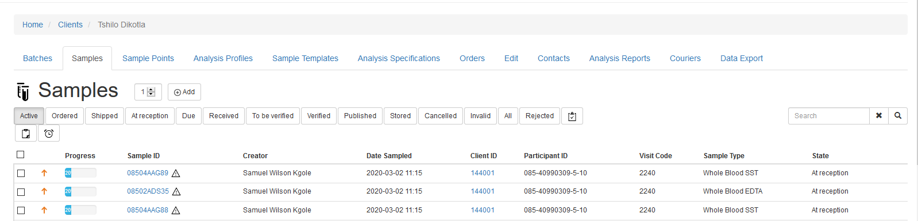

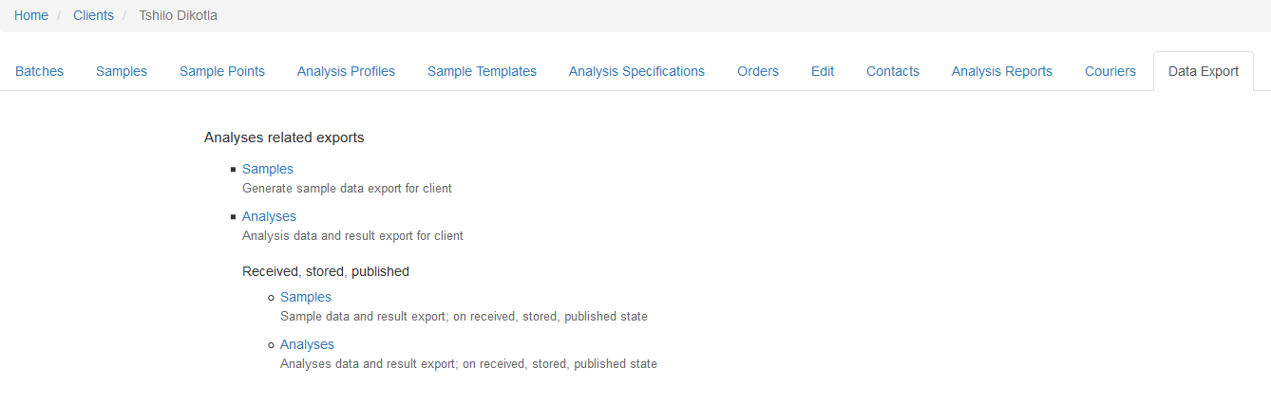

**Question**: What are the differences between running an export file from “Samples” vs. “Analyses”?

**Step 2a: Under “Samples”, select “Export Data” to export an Excel file.**

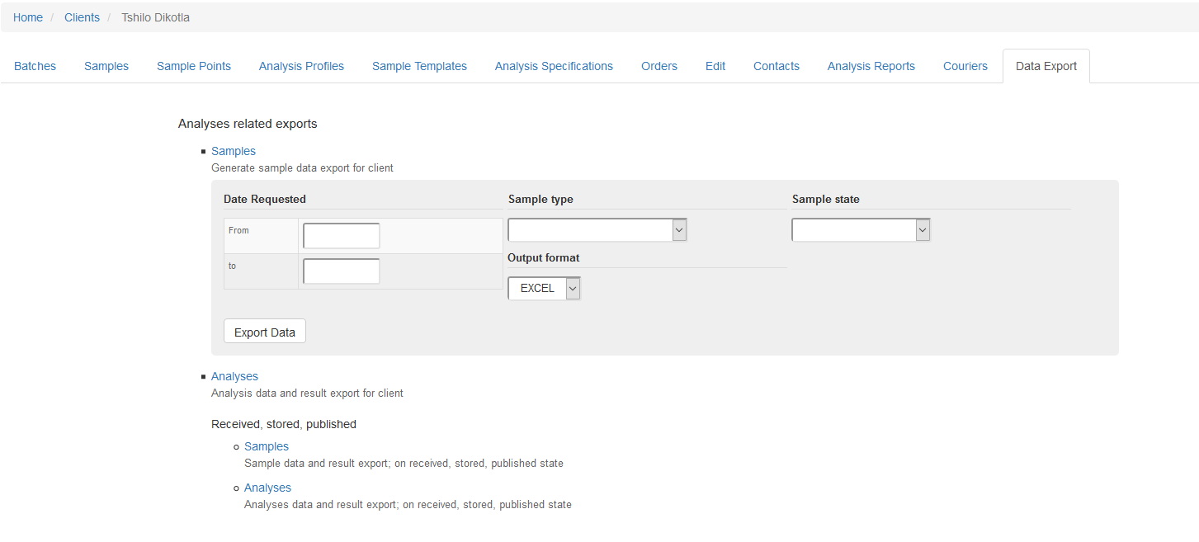

**Question**: What do “Sample Type” and “Sample State” fields represent (see tables below)? Please provide values specific to TD-Karabo studies and define each value.

|  |  |
| --- | --- |
| **Sample Type** | |
| Breast milk (whole) | Viral isolate |
| Breast milk pellet | WBA-BCG |
| Breast milk supernatant | WBA-BCG-PL |
| Buffy coat | WBA-CEL-BCG |
| Cerebrospinal fluid | WBA-CEL-ESAT-6/CFP |
| DNA | WBA-CEL-PHA |
| Dry blood spot | WBA-CEL-UNS (RPMI) |
| FNA | WBA-ESAT-6/CFP |
| Hair | WBA-ESAT-6/CFP – PL |
| PBMC (viable) | WBA-PHA |
| PBMC pellets (non-viable) | WBA-PHA – PL |
| Plasma ACD | WBA-UNS (RPMI) |
| Plasma EDTA | WBA-UNS (RPMI) – PL |
| Plasma EDTA2 | Whole blood ACD |
| Plasma grey top | Whole blood EDTA |
| Plasma HEP | Whole blood grey top |
| RNA | Whole blood lithium heparin |
| Semen | Whole blood paxgene |
| Serum | Whole blood red top (NON) |
| Sputum | Whole blood sodium heparin |
| Stool | Whole blood SST |
| Swab |  |
| Swab faecal |  |
| Urine |  |

|  |
| --- |
| **Sample State** |
| Sampled |
| To be sampled |
| At reception |
| At point of testing |
| Sample registered |
| Scheduled sampling |
| Sent to point of testing |
| Shipped |
| Disposed |
| Rejected |
| To be preserved |
| Ordered |
| Expired |

**Step 2b: Under “Analyses”, select “Export Data” to export an Excel file.**

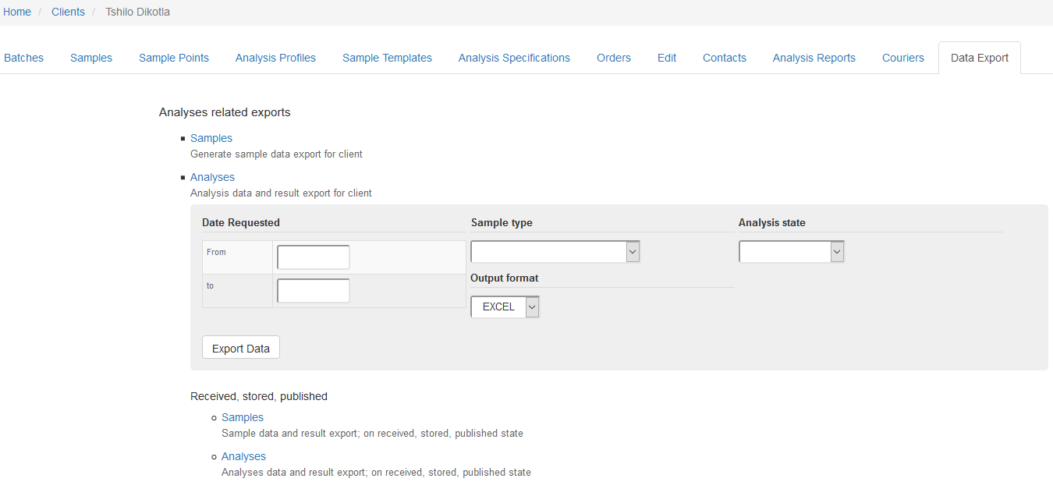

**Question**: What do “Sample Type” and “Analysis State” fields represent (see tables below)? Please provide values specific to TD-Karabo studies and define each value.

|  |  |
| --- | --- |
| **Sample Type** | |
| Breast milk (whole) | Viral isolate |
| Breast milk pellet | WBA-BCG |
| Breast milk supernatant | WBA-BCG-PL |
| Buffy coat | WBA-CEL-BCG |
| Cerebrospinal fluid | WBA-CEL-ESAT-6/CFP |
| DNA | WBA-CEL-PHA |
| Dry blood spot | WBA-CEL-UNS (RPMI) |
| FNA | WBA-ESAT-6/CFP |
| Hair | WBA-ESAT-6/CFP – PL |
| PBMC (viable) | WBA-PHA |
| PBMC pellets (non-viable) | WBA-PHA – PL |
| Plasma ACD | WBA-UNS (RPMI) |
| Plasma EDTA | WBA-UNS (RPMI) – PL |
| Plasma EDTA2 | Whole blood ACD |
| Plasma grey top | Whole blood EDTA |
| Plasma HEP | Whole blood grey top |
| RNA | Whole blood lithium heparin |
| Semen | Whole blood paxgene |
| Serum | Whole blood red top (NON) |
| Sputum | Whole blood sodium heparin |
| Stool | Whole blood SST |
| Swab |  |
| Swab faecal |  |
| Urine |  |

|  |
| --- |
| **Analysis State** |
| Sampled |
| To be verified |
| Sample due |
| Verified |
| Retracted |
| Received |
| Registered |
| To be sampled |
| Rejected |
| Not requested |
| Assigned |
| Attachment due |
| Unassigned |
| Published |
| Cancelled |
| To be preserved |

**HOW TO INTERPRET EXPORT FILES**

|  |  |  |
| --- | --- | --- |
| **EXAMPLES** | **SAMPLES FILE**  **(n= 6085 sample IDs)** | **ANALYSES File**  **(n= 7538 sample IDs; 2892 duplicates)** |
| **PID:** 9-6-10  **EDC Req ID:** 99VPDV3  **EDC Panel:** PBMC plasma (store) | **-Sample IDs (unique):** 9  **-Sample types:** 1 WB, 5 PBMC, 3 plasma  **-Sample state:** 9 stored  **-Status:** N/A  **-Analysis:** N/A | **-Sample IDs (unique):** 6  **-Sample types:** 1 WB, 2 PBMC, 3 plasma  **-Sample state:** N/A  **-Status:** 6 registered  **-Analysis:** 4 PBMC storage, 6 plasma storage |
| **PID:** 18-1-10  **EDC Req ID:** 99YNAP3  **EDC Panel:** PBMC plasma (store) | **-Sample IDs (unique):** 12  **-Sample types:** 1 WB, 7 PBMC, 4 plasma  **-Sample state:** 12 stored  **-Status:** N/A  **-Analysis:** N/A | **-Sample IDs (unique):** 10  **-Sample types:** 1 WB, 7 PBMC, 2 plasma  **-Sample state:** N/A  **-Status:** 10 registered  **-Analysis:** 18 PBMC storage, 4 plasma storage |
| **PID:** 96-2-10  **EDC Req ID:** 99AW7FG  **EDC Panel:** Serum (store) | **-Sample IDs (unique):** 2  **-Sample types:** 2 WB SST  **-Sample state:** 2 sample received  **-Status:** N/A  **-Analysis:** N/A | **-Sample IDs (unique):** 2  **-Sample types:** 2 WB SST  **-Sample state:** N/A  **-Status:** 2 unassigned  **-Analysis:** 2 serum storage |
| **PID:** 122-0-10  **EDC Req ID:** 99V9N6X  **EDC Panel:** Insulin | **-Sample IDs (unique):** 2  **-Sample types:** 1 WB SST, 1 serum  **-Sample state:** 1 sample at reception, 1 stored  **-Status:** N/A  **-Analysis:** N/A | **-Sample IDs (unique):** 2  **-Sample types:** 1 WB SST, 1 serum  **-Sample state:** N/A  **-Status:** 2 registered  **-Analysis:** 2 insulin |
| **PID:** 555-6  **EDC Req ID:** 99CB9ZR  **EDC Panel:** Viral load | **-Sample IDs (unique):** 4  **-Sample types:** 1 WB EDTA, 1 buffy coat, 2 plasma EDTA  **-Sample state:** 1 sample received, 2 stored, 1 published  **-Status:** N/A  **-Analysis:** N/A | **-Sample IDs (unique):** 4  **-Sample types:** 1 WB EDTA, 1 buffy coat, 2 plasma EDTA  **-Sample state:** N/A  **-Status:** 4 registered, 2 published  **-Analysis:** 2 buffy coat storage, 2 HIV viral load (RNA PCR), 2 plasma storage |